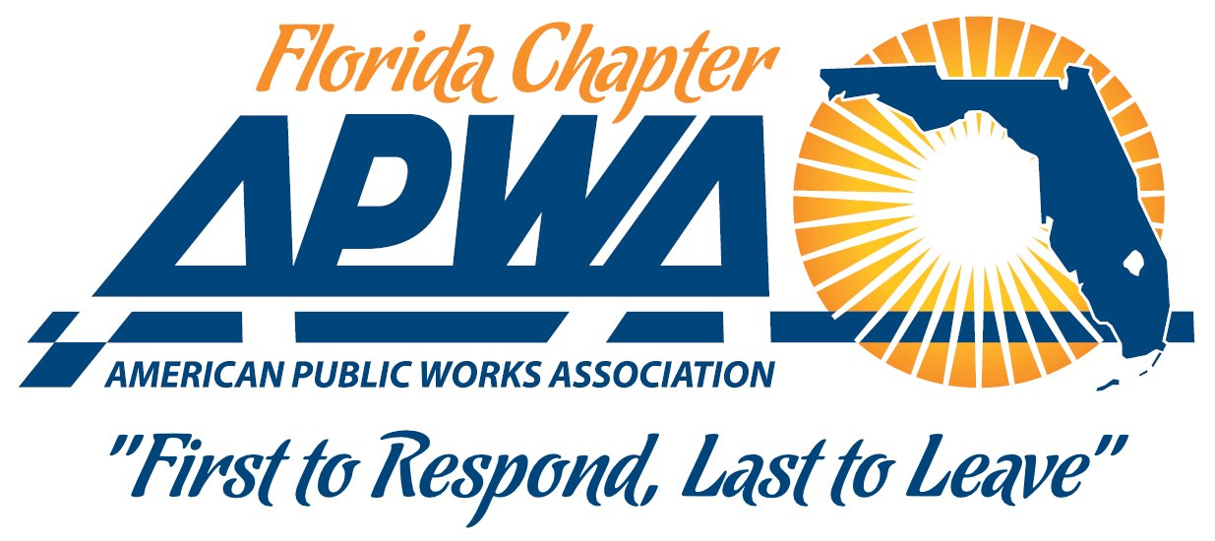

To: President Tom Pugh and Members of the Executive Committee
From: Mark E. Collins – By-Laws Committee Chair
Date: June 26th, 2026
RE: By-Laws Committee Report
It was brought to my attention that the By-Laws that were submitted in August 2025 were not officially approved so I have resubmitted them with additional verbiage in Article VI, section 5 adding the words “a current copy of the Branch By-Laws,” and corrected dates at the bottom of each page.

