To: President Tom Pugh and Members of the Executive Committee
From: George Su, District Representative
Cc: Amy Serles, Big Bend Branch Chairman
Date: June 8, 2026
RE: 9-District II Big Bend Branch Report
To celebrate the National Public Works Week, the City of Tallahassee’s Mayor John Dailey presented a Proclamation at the commission Meeting on May 13 declaring May 17 – 23 as Public Works week in Tallahassee. He commended the efforts, and success achieved, by City employees across all facets of public works along with all associated public works professionals. See the presented Proclamation at the end of report (Attachment 1) and group picture for reference (Figure 1).
On Thursday, May 21st at the Leon County Apalachee Regional Park, we held the American Public Works Association Big Bend Branch’s 30th Annual ROAD-E-O to showcase the skill, professionalism, and commitment of our public works workforce while fostering camaraderie and friendly competition among neighboring agencies. The theme this year is based on the National Public Works Week theme “Rooted in Service, Powered by Community.”
A total of sixteen (16) teams participated in the competition of sixteen (16) evets: 9 teams from the City of Tallahassee, 3 teams from Leon County, 2 teams from Jefferson County, 1 team from Wakulla County, and 1 team from Talquin Electric Cooperative, Inc. The City of Tallahassee’s teams won the 1st Place for nine events. However, Leon County’s “Renegade Reapers” team won the Overall 1st Place and took home the magnificent trophy to proudly display in their office until the next year’s Road-E-O. The overall attendance is estimated to be over three hundred (300) people. This year’s Road-E-O competition was another success and provided a great opportunity to celebrate the expertise and dedication of public works professionals throughout the Big Bend Branch (Figures 2 and 3).
At our June 4th membership meeting, our featured speaker, Gevin McDaniel, PE from SpanPath, gave an overview of innovative strategies for accommodating pedestrians in active work zones, with a focus on safety, accessibility, and compliance. Gevin’s presentation included 1 PDH / 0.1 CEU credits and covered key updates in the 11th Edition of the MUTCD and a review of applicable FDOT Developmental Specifications and associated APL products. He also demonstrated the application for each of the device types to improve the designer’s effectiveness in pedestrian temporary traffic control planning. His presentation was very informative and well received by our 25 members in attendance.
At this meeting we also celebrated our longtime serving member Debbie Warren’s retirement from Leon County Public Works for her 38 years of dedicated service as a public employee. Debbie has served the Big Bend Branch as treasurer, secretary, vice chair and chairman, as well as the State Chapter for the membership committee chairman. Her service has been a major factor to the success of the branch, specifically for each and every event from the Annual Awards Banquet to the Road-E-O. Our State Chapter Vice President Joe Sisk presented Debbie a parting gift to show our appreciation for her contribution to the Big Bend Branch (Figure 4).

Respectfully submitted,

George Su

Attachment 1
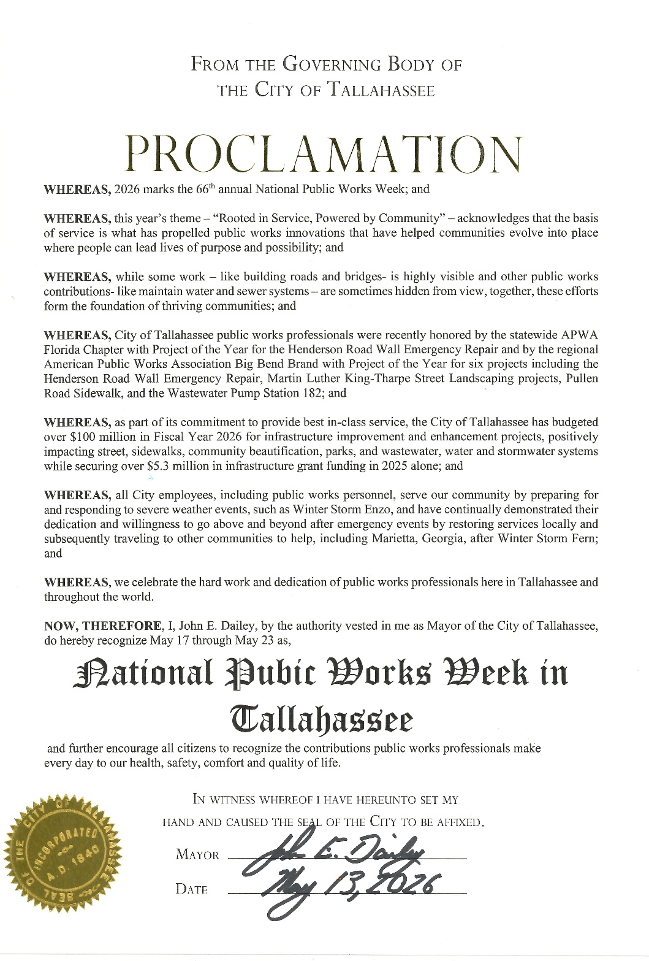

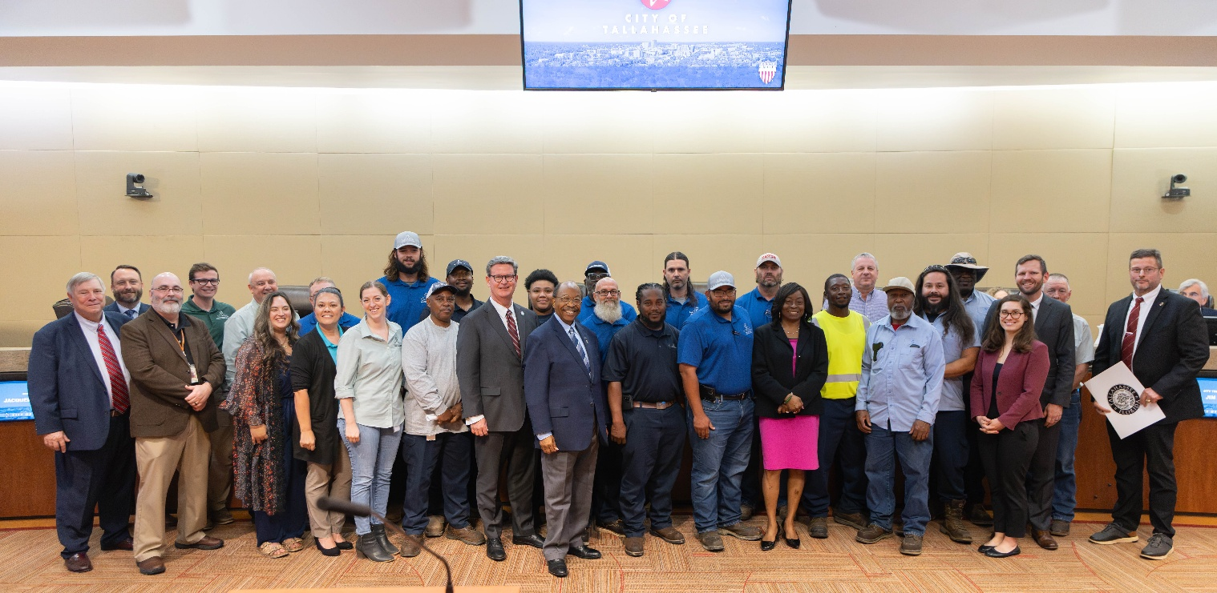
Figure 1 City’s Commission Meeting on May 13

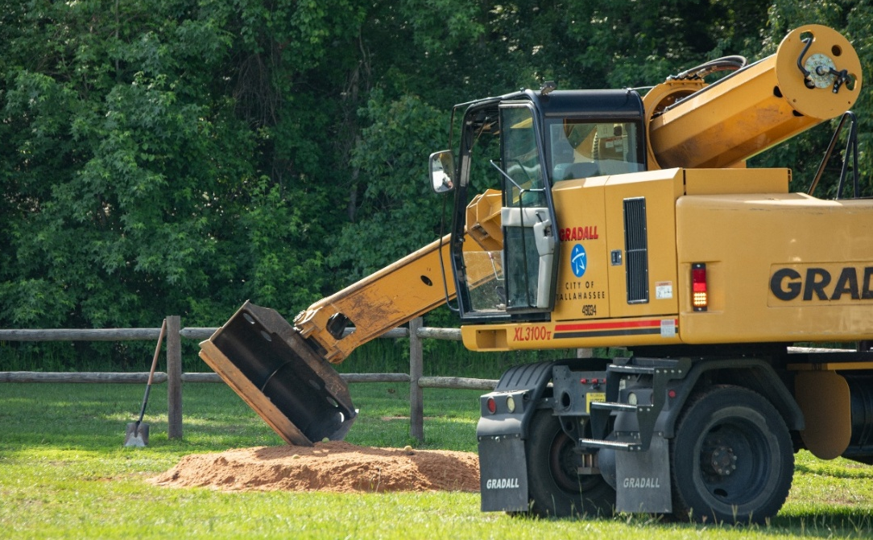
Figure 2 Road-E-O Gradall Event

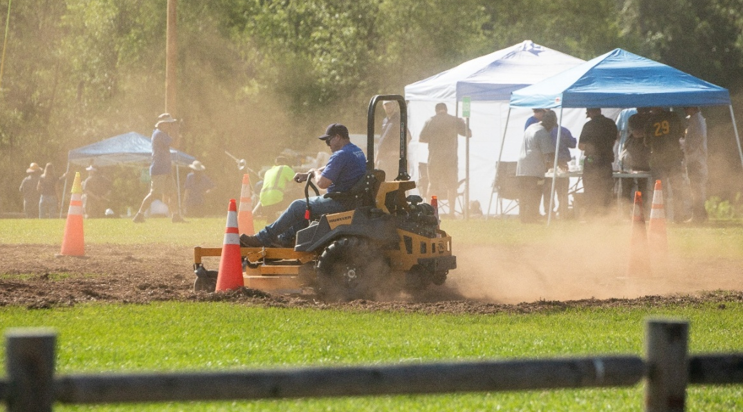
Figure 3 Road-E-O Mower Event

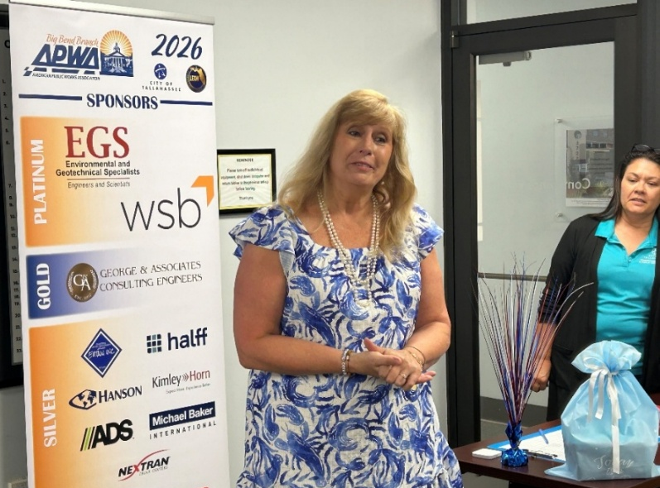
Figure 4 June 4 Membership Meeting – Debbie Warren’s retirement celebration

